**English Pear & Fresia**

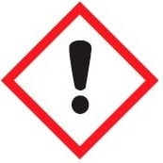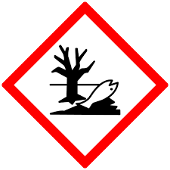**Warning.**

Substances: 2-Methyl-3-(p-isopropylphenyl)propionaldehyde, Formaldehyde cyclododecyl ethyl acetal, Hexyl salicylate, Linalool, Linalyl acetate, [1.alpha.(E),2.beta.]-1-(2,6,6-Trimethyl-3-cyclohexen-1-yl)-2-buten-1-one, alpha,alpha-Dimethyl-pethylphenylpropanal, d-Limonene, dl-Citronellol.

H315 Causes skin irritation. H317 May cause an allergic skin reaction. H319 Causes serious eye irritation. H410 Very toxic to aquatic life with long lasting effects. P102 Keep out of reach of children. P302/352 IF ON SKIN: Wash with plenty of soap and water. P305+P351+P338 - IF IN EYES: Rinse cautiously with water for several minutes. Remove contact lenses, if present and easy to do. Continue rinsing. P501 Dispose of contents/container in accordance with local regulations.

UFI:

Your Business Name, Adress Line 1, Town/City, Postal, Country

Phone

220g Net